DMAT – Project 1

Name : Siddhi Kate Student Number: ­ 2982006

#### Initial Tasks

* **Title**: Prediction of 5-Year Career Longevity for NBA Rookies.
* **Data description:** A description of the data in detail under the following subheadings:
  + **The problem domain**

The dataset includes 21 attributes and 1341 values. Most of the values are numeric. The class attribute has the values 0 and 1 with **0 being ‘No’ and 1 being ‘Yes’** This a dataset consisting of NBA rookies and our task is to predict if they will be playing in the NBA after 5 years.

* + **The source of the data**

<https://data.world/exercises/logistic-regression-exercise-1>

The dataset is available on data.world and is available as a classification exercise.

* + **The agencies working with the data**

The dataset is used as an exercise for classification and currently no agencies are working with the data.

* + **The intended use of the data**

The purpose of the data is to help NBA coaches select a player that can last in the league for a long term.

* + **The attribute types of the data**

Nominal and numeric

**Table**: Details of attribute names

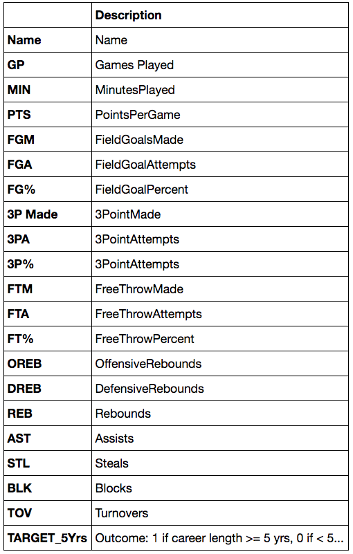

* **Objective**: To Predict 5-Year Career Longevity for NBA Rookies.
* **Summary of Findings**: With roughly 70% accuracy we have predicted a 5-Year Career Longevity for NBA Rookies.

## 2. Preprocessing – 10%

In this section you should

1. Identify the set of preprocessing techniques that can be applied to your data and clearly indicate which techniques are appropriate and which ones are not.
2. Provide evidence through screenshot of the effects of preprocessing the data along with a short explanation.
3. Generate a file called dataset.arff which is the outcome of the preprocessing.

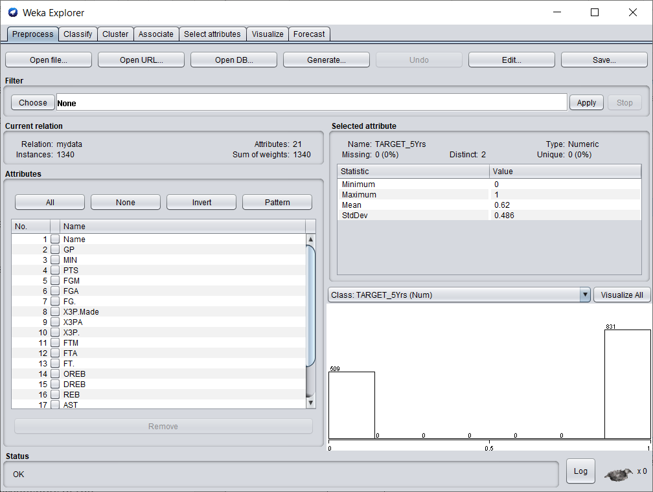

All the values of the original dataset before preprocessing.

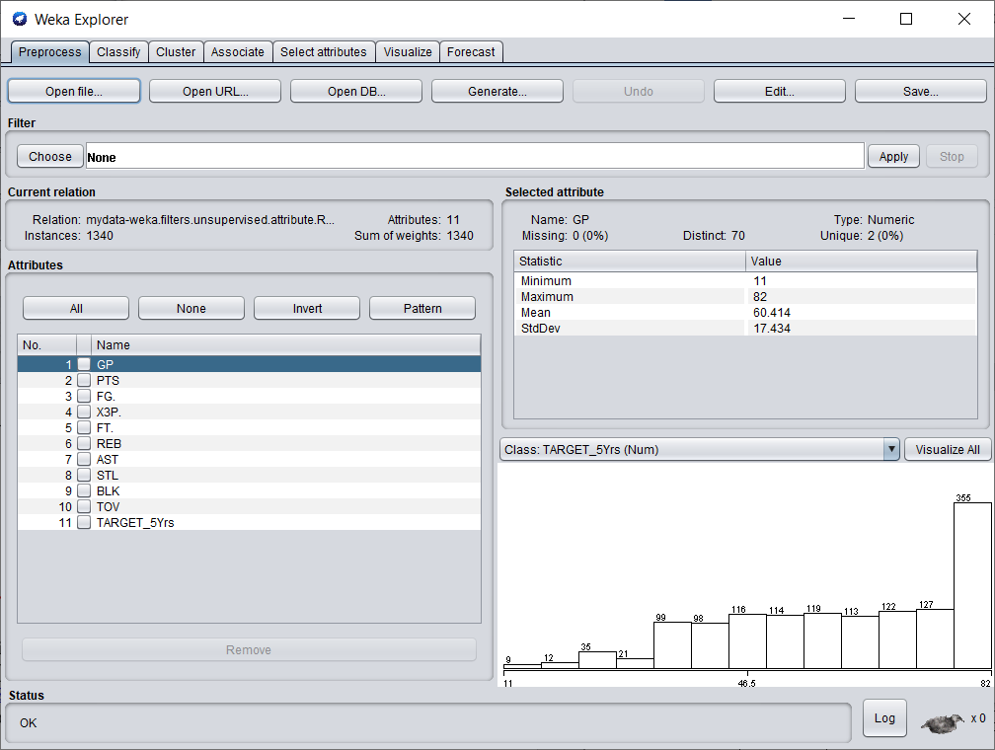

Names of players was removed as it had many unique values which would cause overfitting and had no value whatsoever. MIN (minutes played) was removed because we are already using games played attribute. FGM(Field goals made),FGA(field goal attempts),3P Made (3 points made),3PA(3 point attempts),FTM(free throws made),FTA(free throw attempts),OREB(offensive rebounds),DREB(defensive rebounds) are all removed since we already have attributes like FG(field goal percent),3P(3PointPercent) , FT(Free throw %),REB(rebounds) that provide the same use and removes redundancy. All the values are numeric and need to be discretized.

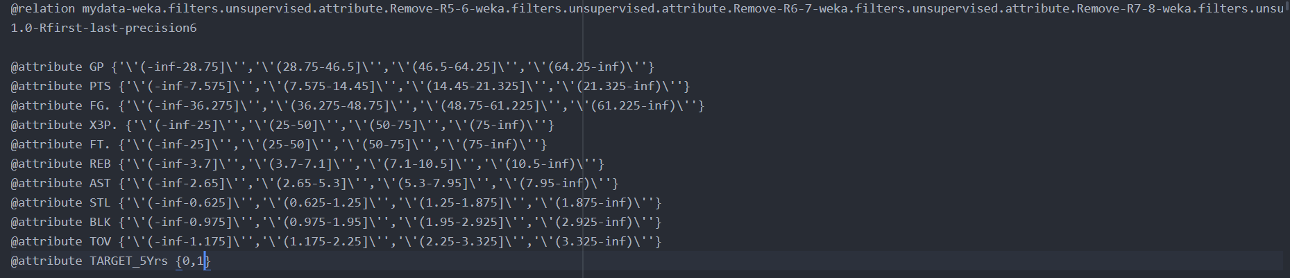

These are the attributes of the dataset after discretization on a text editor. However, these values cannot be in fractions and hence we need to manually convert them to whole numbers.

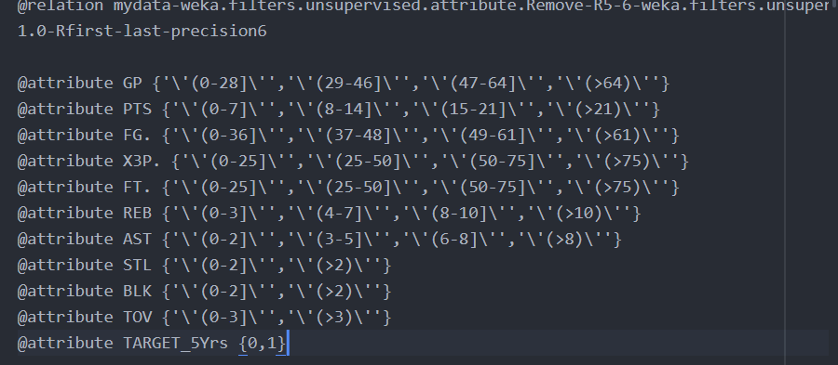

These are the attributes of the dataset after converting the discretized values from fractions into whole numbers. The class attribute is TARGET_5Yrs with the 0 being ‘No’ and 1 being ‘Yes’. The dataset is now ready for classification.

## 3. Divide your dataset into training and test set – 0%

Follow the instructions presented in the link below divide the test into a training and testing set in the ration of (9:1).

<https://www.youtube.com/watch?v=uiDFa7iY9yo>

The files generated as part of this process should be saved and submitted as the following

* trainingSet.arff and
* testingSet.arff

Screen shorts of these files should be included.

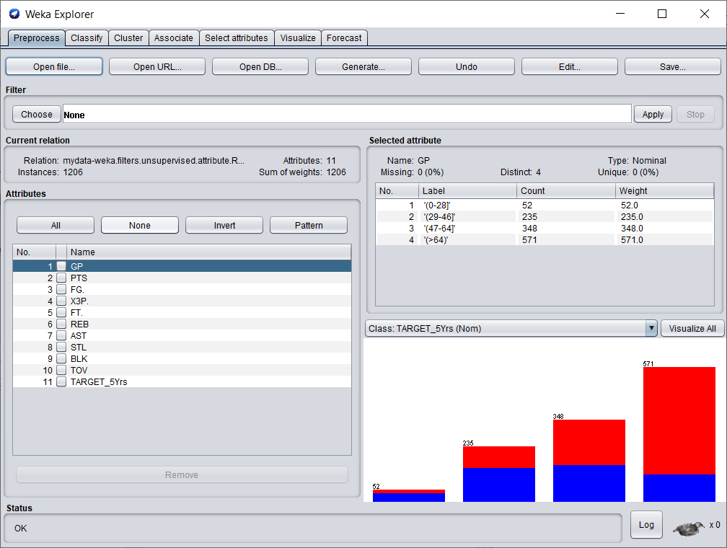

This is the training dataset and it has 1206 instances.

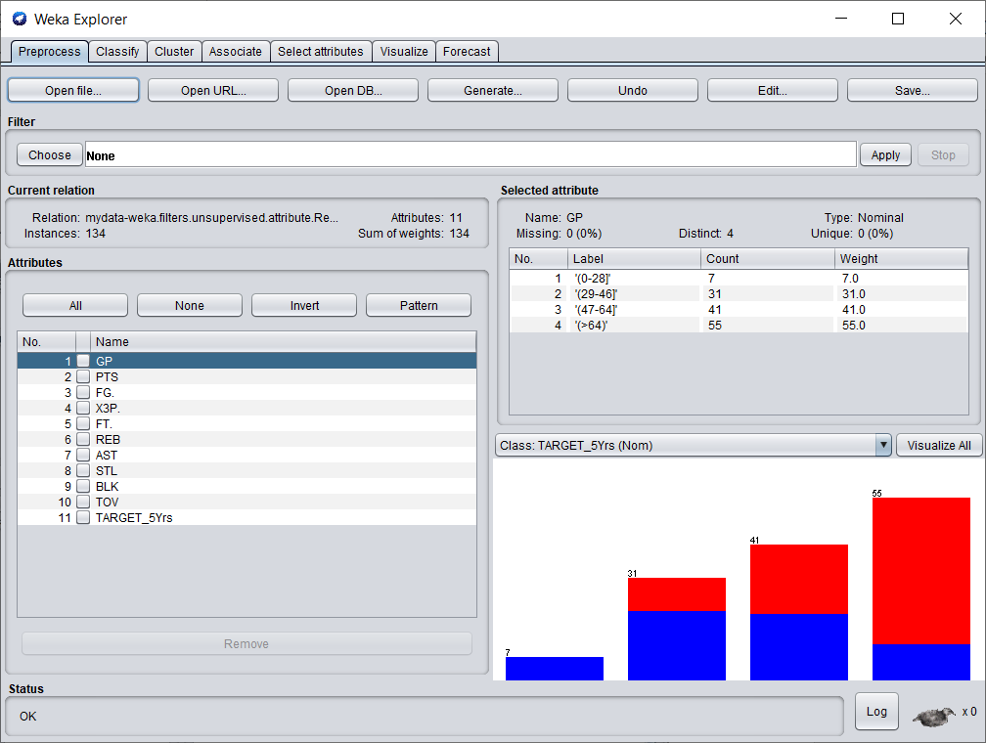

This is the testing dataset and it has 134 instances.

#### Data Mining Techniques

# Classification / Association

For each of the following classification techniques

1. Train your model using trainingSet.arff
2. Test your model using testingSet.arff
3. Write a few paragraphs analyzing the results. Be sure to vary parameters at least 3 times in each case. Support this analysis with screenshots of the following
   1. The model or a visualization of the model
   2. The results of the model
   3. Any additional output of the model including but not limited to
      1. Rules
      2. Confidence Values
      3. Confusion Matrixes
      4. etc
   4. Simple references to the notes or URL links to online resources complete with a sentence or two of explanation.

## 4. Classification/ Association: J48 Tree or Association Rules – 10%

Training Model:

1. Test 1

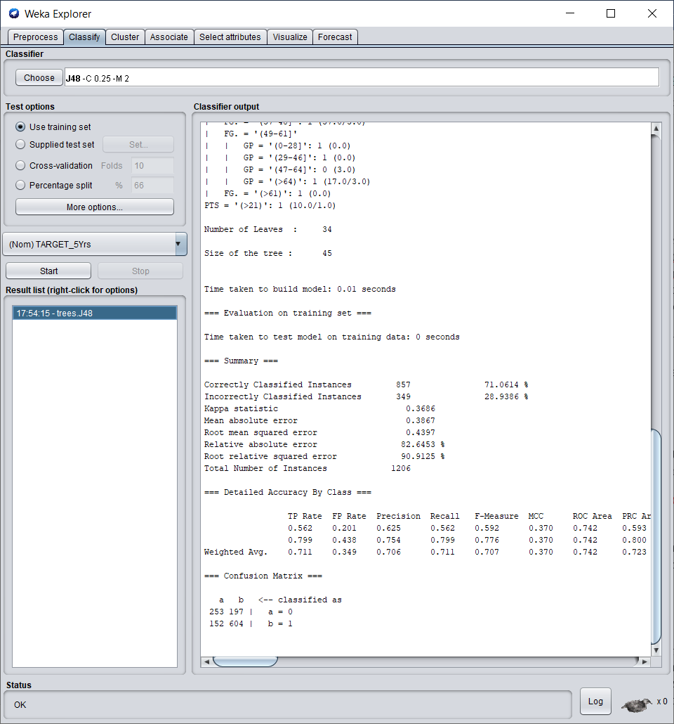

We run the J48 algorithm on the training dataset with a confidence of 0.25 and a minimum no of objects as 2. We get around 71% correctly classified instances.

––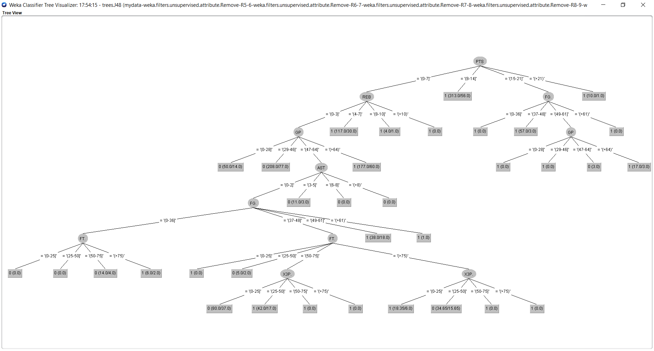

This is the visualisation of the J48 tree for Test 1. The tree has too many branches and even though detailed is tougher to grasp. We run the next test by increasing the confidence value.

1. Test 2

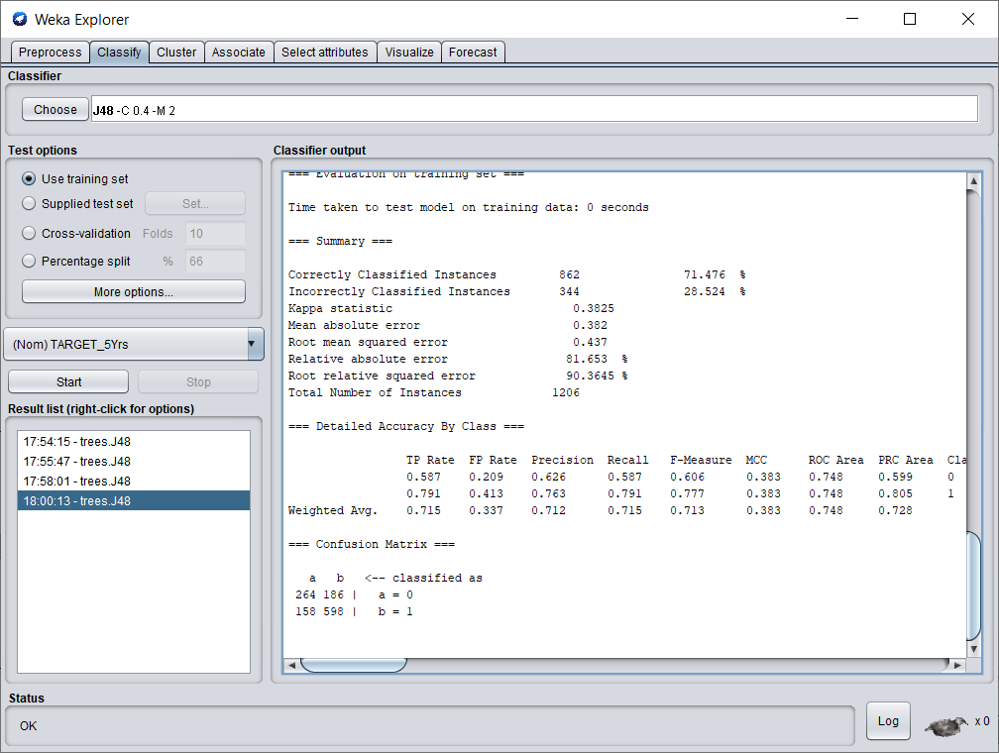

We run the J48 algorithm on the training dataset with a confidence of 0.4 and a minimum no of objects as 2. We get around 71.47% correctly classified instances. The instances are classified slightly better than the previous test.

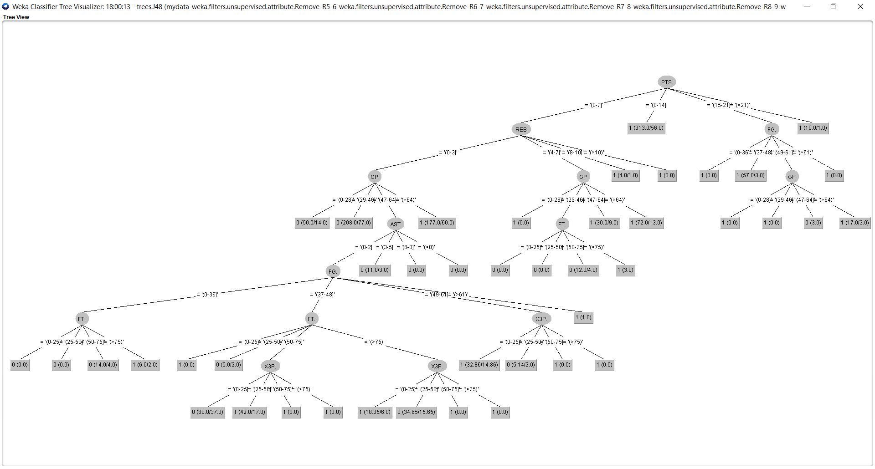

This is the visualisation of the J48 tree for Test 2 . The tree has too many branches and even though detailed is tougher to grasp. It seems even more complicated than the previous test. We run the next test by decreasing the confidence value.

1. Test 3

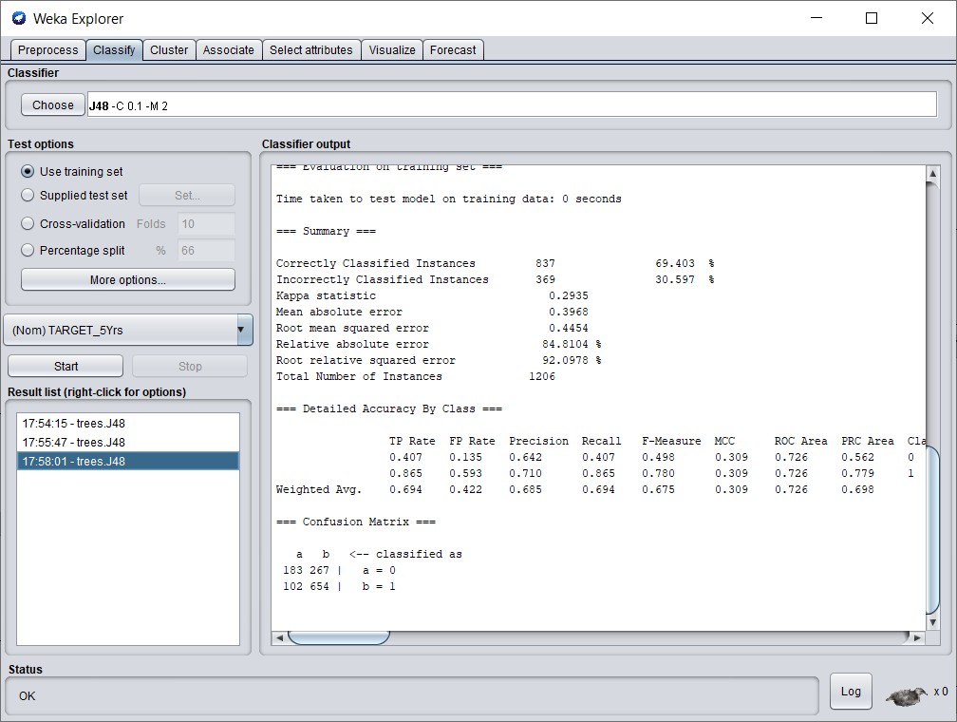

We run the J48 algorithm on the training dataset with a confidence of 0.1 and a minimum no of objects as 2. We get around 69.4% correctly classified instances. The instances are classified slightly worse than the previous two tests.

–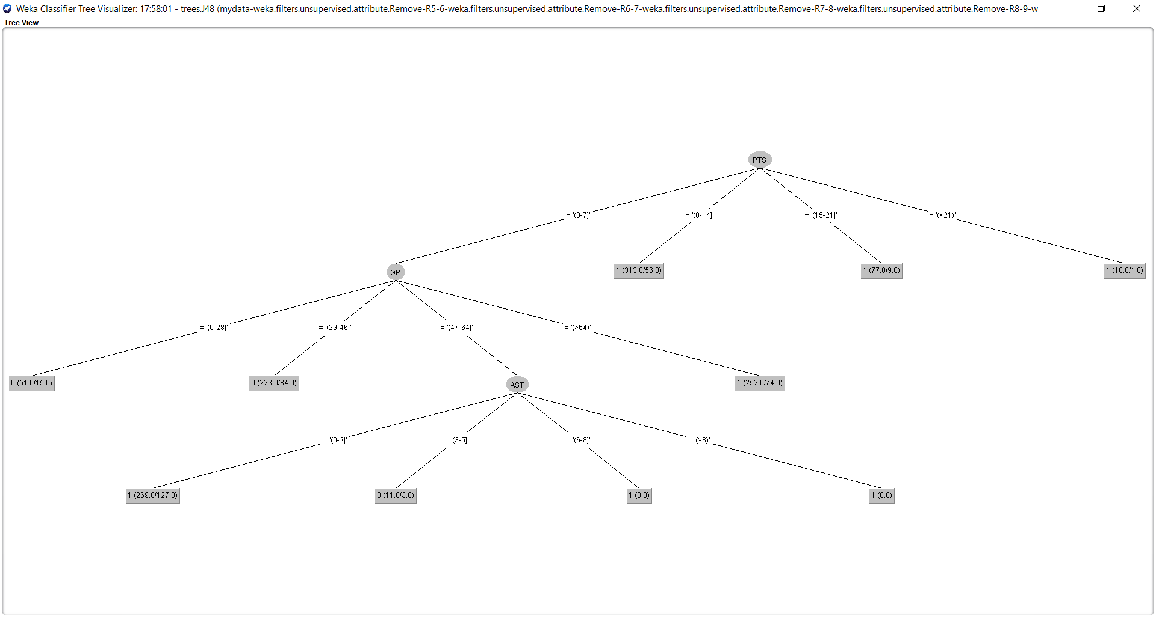

This is the visualisation of the J48 tree for Test 3. The tree seems easy to understand and looks better than the previous 2 tests.

Testing model:

1. Test 4



We run the J48 algorithm on the testing dataset with a confidence of 0.25 and a minimum no of objects as 2. We get around 71% correctly classified instances.



This is the visualisation of the J48 tree for Test 4. The tree is similar to the tree from the training test with the same confidence value.The tree has too many branches and even though detailed is tougher to grasp. We run the next test by decreasing the confidence value.

1. Test 5

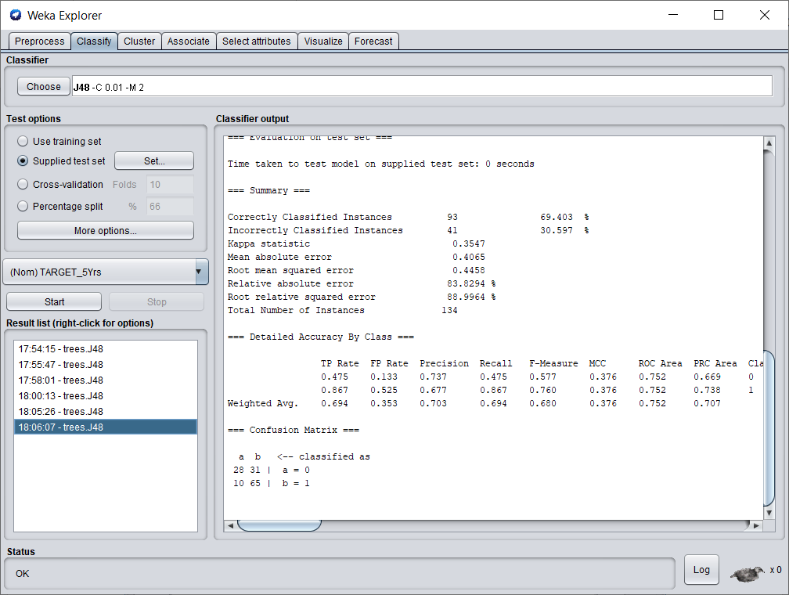

We run the J48 algorithm on the testing dataset with a confidence of 0.01 and a minimum no of objects as 2. We get around 69.4% correctly classified instances which is lesser than the previous test.

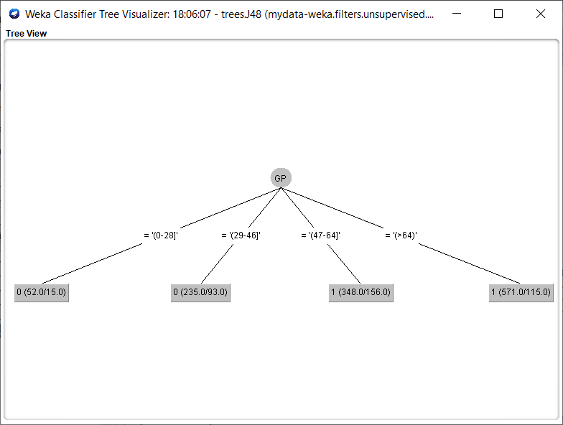

This is the visualisation of the J48 tree for Test 5. Because of setting the confidence level to 0.01, we get an overtly simple tree with very few branches. The tree doesn’t seem to be very useful. We run the next test by increasing the confidence value.

1. Test 6

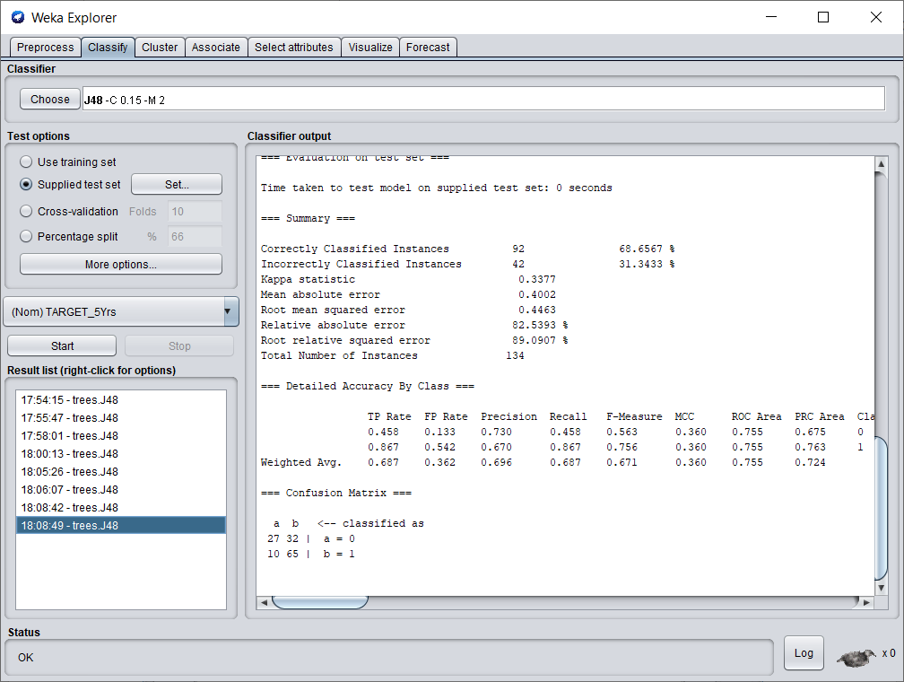

We run the J48 algorithm on the testing dataset with a confidence of 0.15 and a minimum no of objects as 2. We get around 68.6% correctly classified instances which is lesser than the previous test.

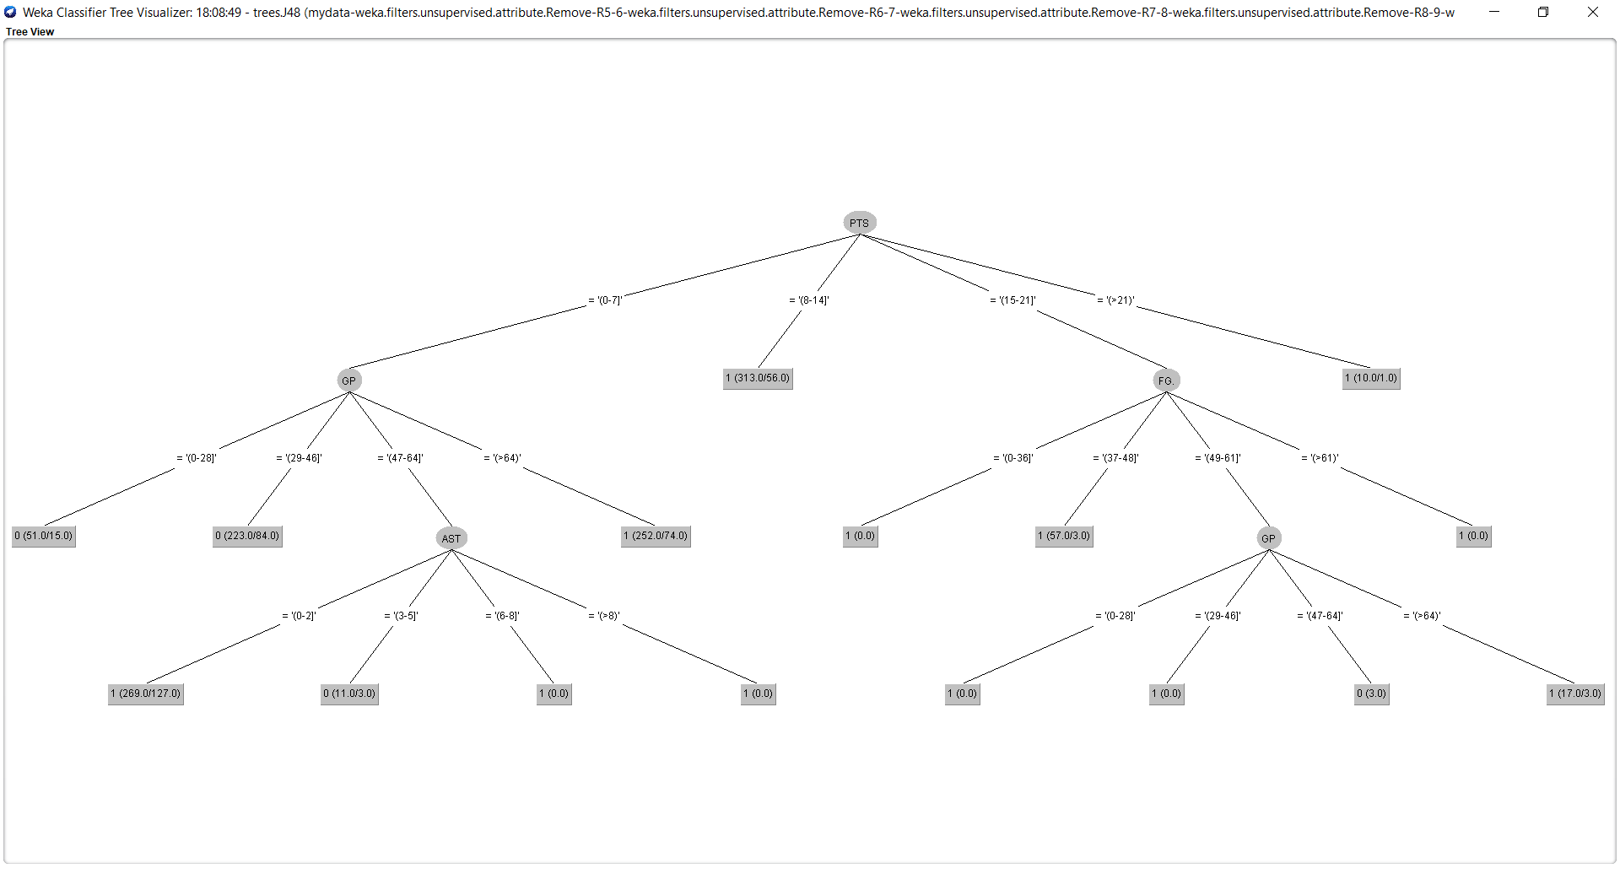

This is the visualisation of the J48 tree for Test 6. The tree seems easy to understand and looks better than the previous 2 tests.

## 5. Classification: MLP or a similar advanced technique from Weka – 15%

Steps :

1. Initially, we load the training set in the weka.
2. Then we open the classify tab and select the Multilayer Perceptron in the functions section.
3. By clicking on the tab, next to the choose button we configure the multilayer perceptron.
4. Here , we have used three hidden layers namely having 3,6,2 nodes respectively.
5. We set the value of GUI to true.
6. Next we run the algorithm.
7. The following image is the neural network that is obtained.

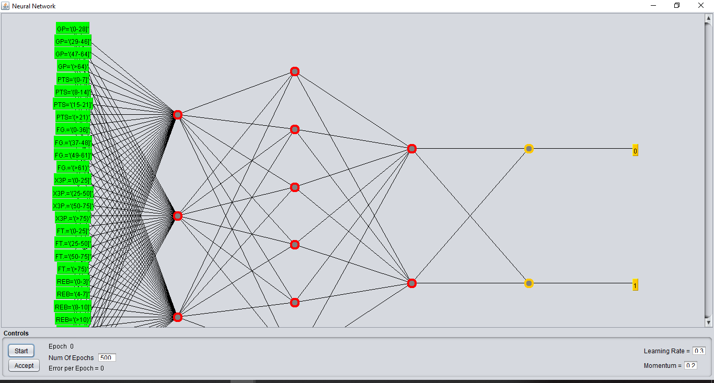

1. As we have many attributes, the layer in green is the layer of inputs.
2. We have the outputs 0(no) and 1(yes) in yellow.
3. The result obtained in weka is as follows:

=== Evaluation on training set ===

Time taken to test model on training data: 0 seconds

=== Summary ===

Correctly Classified Instances 860 71.3101 %

Incorrectly Classified Instances 346 28.6899 %

Kappa statistic 0.4065

Mean absolute error 0.3734

Root mean squared error 0.4329

Relative absolute error 79.8186 %

Root relative squared error 89.5157 %

Total Number of Instances 1206

=== Detailed Accuracy By Class ===

TP Rate FP Rate Precision Recall F-Measure MCC ROC Area PRC Area Class

0.698 0.278 0.599 0.698 0.645 0.410 0.761 0.598 0

0.722 0.302 0.801 0.722 0.759 0.410 0.761 0.826 1

Weighted Avg. 0.713 0.293 0.725 0.713 0.717 0.410 0.761 0.741

=== Confusion Matrix ===

a b <-- classified as

314 136 | a = 0

210 546 | b = 1

Summary of findings: We have achieved an accuracy level of 71% which is similar to J48 classsification.

# Clustering

#### Initial Tasks

## 1. Description of your dataset and findings – 20%

* **Title**: Using the Simple K-means clustering algorithm to cluster user reviews on different types of tourists places in East Asia. The user ratings range from 0 to 4 with 0 being the lowest and 4 being the highest.
* **Data description:** A description of the data in detail under the following subheadings:
  + The problem domain: The dataset includes 11 attributes and 980 tuples. The user reviews are numeric values ranging from 0 to 4. This is a social media dataset and is built from trip advisor data. The problem definition is to group types of tourists places based on user reviews.
  + The source of the data: The dataset was obtained from UCI Machine LearningRepository. [https://archive.ics.uci.edu/ml/datasets/Travel+Reviews#](https://archive.ics.uci.edu/ml/datasets/Travel+Reviews)
  + The agencies working with the data : This dataset was used by the professors of Cochin University of Science and Technology(CUSAT), Kochi, India as a part of research.
  + The intended use of the data : This data is to used to test various clustering algorithms like K- means, K-mediods, CLARA etc.
  + The attribute types of the data : The dataset has 11 attributes and they are as follows :

1. User id : Unique user id (Nominal)
2. Category 1 : Average user feedback on art galleries (Numeric)
3. Category 2 : Average user feedback on dance clubs (Numeric)
4. Category 3 : Average user feedback on juice bars (Numeric)
5. Category 4 : Average user feedback on restaurants (Numeric)
6. Category 5 : Average user feedback on museums (Numeric)
7. Category 6 : Average user feedback on resorts (Numeric)
8. Category 7 : Average user feedback on park/picnic spots (Numeric)
9. Category 8 : Average user feedback on beaches (Numeric)
10. Category 9 : Average user feedback on theaters (Numeric)
11. Category 10 : Average user feedback on religious institutions.(Numeric)

The following image shows the csv view of the dataset.

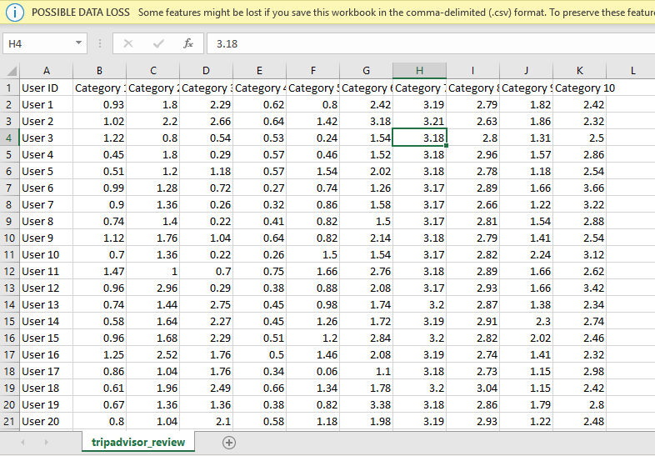

* **Objective**: The technique used on this dataset is K-Means clustering . Two of the numeric attributes will be selected that are most suitable for this algorithm. The main objective is to find clusters of user reviews(based on value of ratings) of the selected 2 types of attributes.

## 2. Preprocessing – 10%

We will be using the Weka software for performing K-means clustering. The following image shows the view of the data in weka.

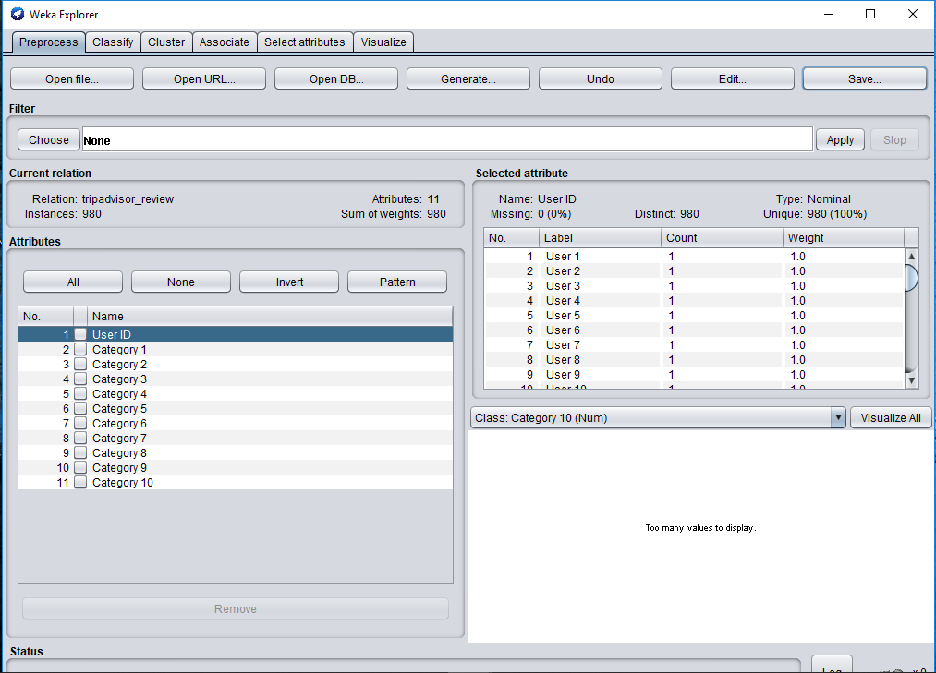

The user id attribute is a nominal attribute and has a different value for every tuple. Hence it is unnecessary for this technique we remove this attribute as shown below:

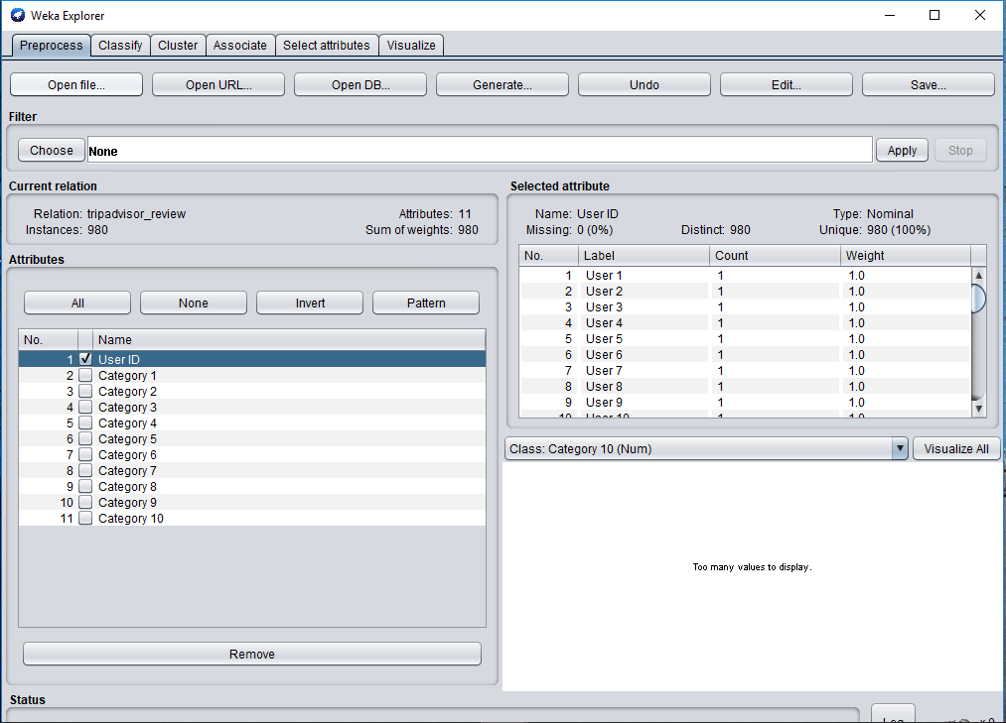

This dataset has no missing values and hence does not require any specific technique for removing the missing values. This can be seen from the following image.

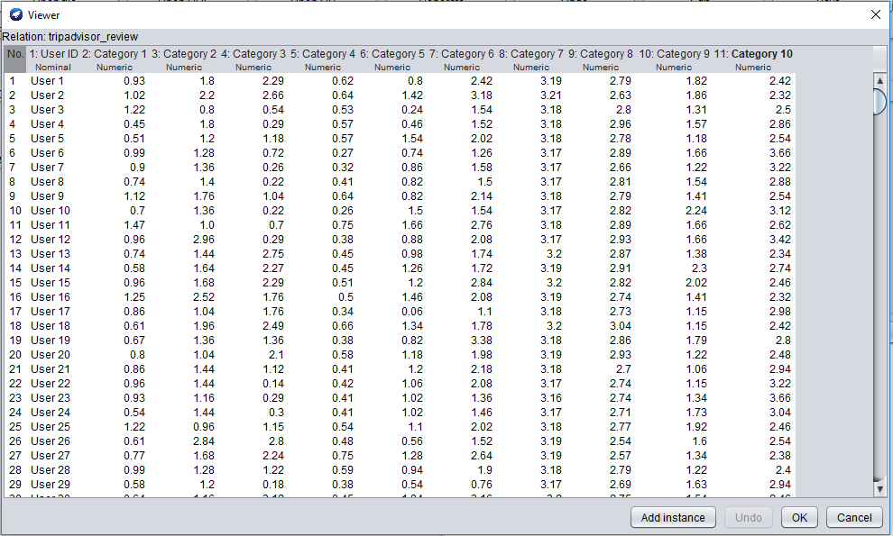

The two attribute that are selected for this are Category 4 and Category 8 . Hence we remove all other attributes as shown below for accurate results. We save the resultant file as dataset-clustering.arff.

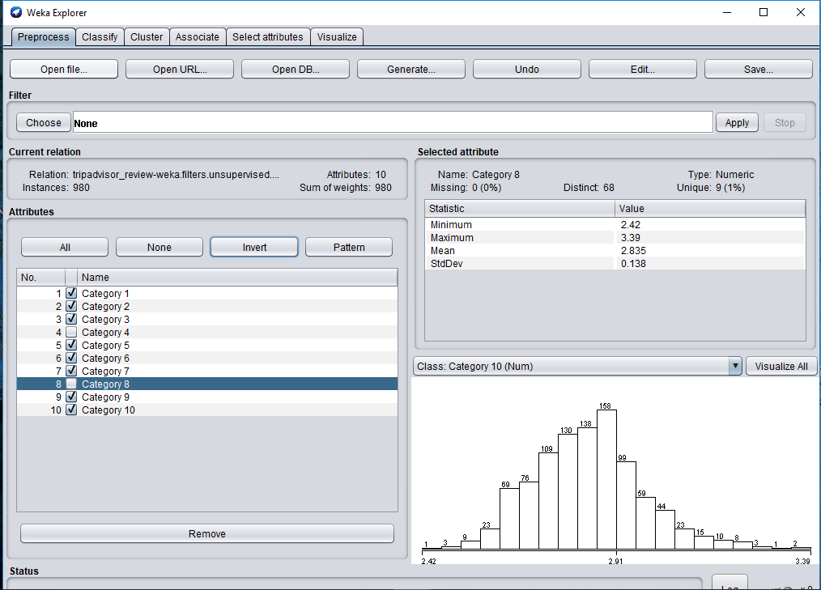

dataset-clustering.arff :

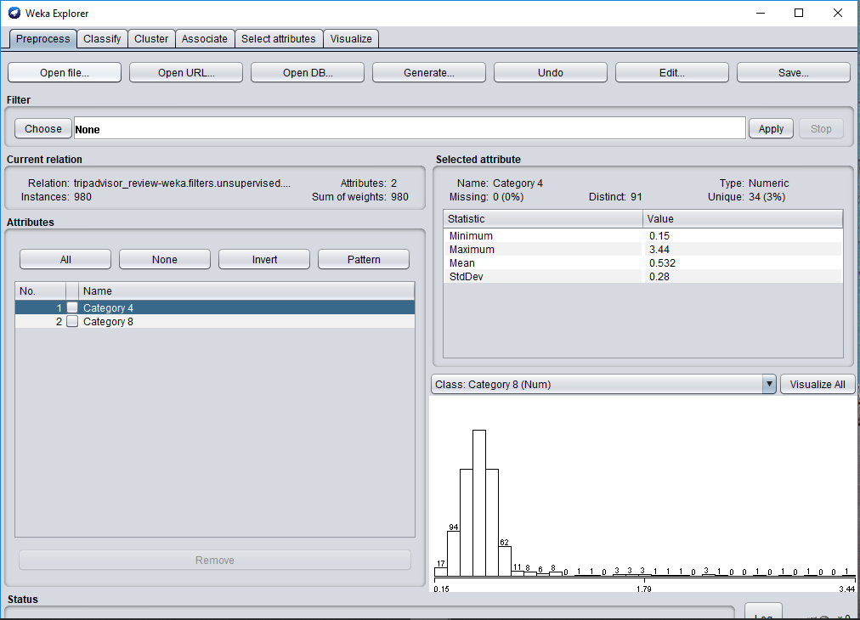

## Clustering: K-Means or DBSCAN – 10%

**The technique used is Simple K-means clustering in Weka.**

Steps :

1. We choose the cluster tab in weka and then choose the Simple K- means algorithm from the choose section . We initially set the value of cluster to 2 clusters and then run the algorithm. The following cluster assignments are obtained:

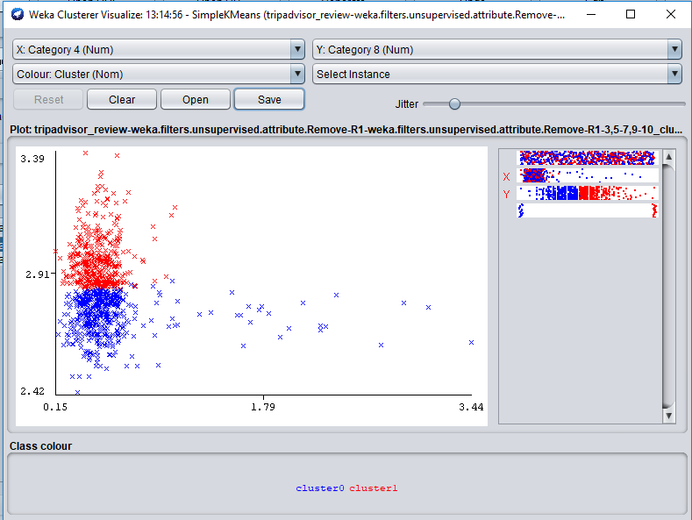

The two clusters are generated in red and blue . However, from the graph we can see that the points that are far away from cluster in blue are also considered in the same cluster.

So now we change the value of cluster to 4 and then the following cluster assignments are obtained :

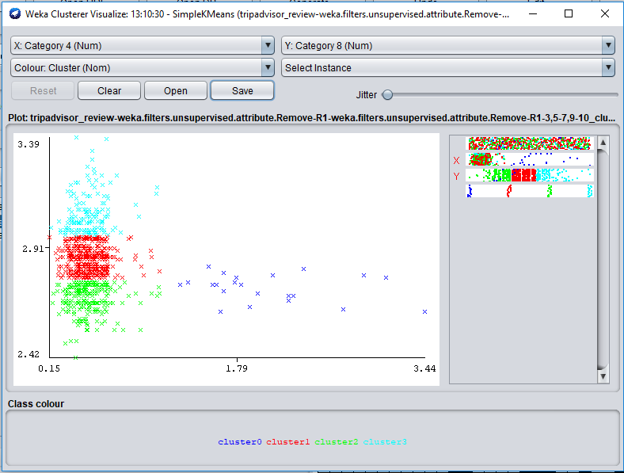

By comparing to the previous clusters, we see that the two large clusters are now converted in 3 clusters. The points of these clusters are close by and can be grouped in fewer clusters.

Hence , now we set the value of clusters to 3 and run the algorithm.

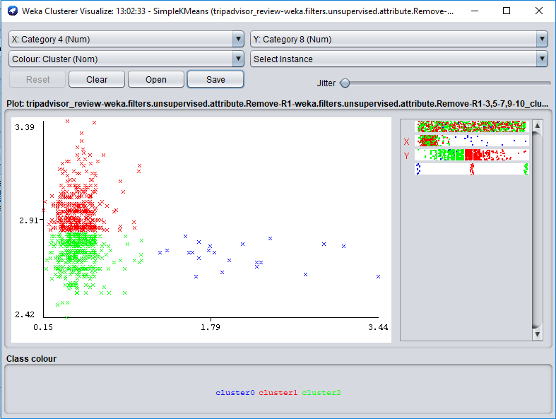

The above result is accurate as compared to the above two. The two main clusters are in red and green and the points that are far away from the cluster are in blue . Hence we select this as our final result.

Result of clustering :

1. The attributes used for clustering are Category 4 ( Average rating for Juice bars) and Category 8 (Average rating for resorts).
2. We set them as follows :

Category 4 : Atrribute on X axis of the graph

Category 8 : Attribute on Y axis of the graph

1. The results obtained after running the experiment in weka are as follows :

=== Run information ===

Scheme: weka.clusterers.SimpleKMeans -init 0 -max-candidates 100 -periodic-pruning 10000 -min-density 2.0 -t1 -1.25 -t2 -1.0 -N 3 -A "weka.core.EuclideanDistance -R first-last" -I 500 -num-slots 1 -S 10

Relation: tripadvisor_review-weka.filters.unsupervised.attribute.Remove-R1-weka.filters.unsupervised.attribute.Remove-R1-3,5-7,9-10

Instances: 980

Attributes: 2

Category 4

Category 8

Test mode: evaluate on training data

=== Clustering model (full training set) ===

kMeans

======

Number of iterations: 8

Within cluster sum of squared errors: 9.891700192070802

Initial starting points (random):

Cluster 0: 0.64,2.79

Cluster 1: 0.53,2.82

Cluster 2: 0.45,2.69

Missing values globally replaced with mean/mode

Final cluster centroids:

Cluster#

Attribute Full Data 0 1 2

(980.0) (22.0) (452.0) (506.0)

========================================================

Category 4 0.5325 2.0536 0.493 0.5016

Category 8 2.8351 2.725 2.9513 2.736

Time taken to build model (full training data) : 0 seconds

=== Model and evaluation on training set ===

Clustered Instances

0 22 ( 2%)

1 452 ( 46%)

2 506 ( 52%)

Visualizing cluster assignments :



Summary of findings :

1. Namely 3 clusters are formed :

Cluster 0 22 ( 2%)(cluster in blue)

Cluster 1 452 ( 46%)(cluster in red)

Cluster 2 506 ( 52%)(Cluster in green)

1. Very few of the user ratings for juice bars are higher than 1. That is juice bars have very low ratings.
2. Comparatively, user ratings for resorts are mostly high ranging from 2.5 to 3.5.
3. Most of the user ratings lie between the range of 2.7 to 3.1 approximately.
4. Finally, user rating for resorts are better than those for juice bars.
5. The graph gets denser as it moves up vertically and it gets sparse as it moves right horizontally.

# Time Series Forecasting

## Time Series Forecasting – 15%

* We use the daily-minimum-temperatures-in-me dataset which has the Daily minimum temperatures in Melbourne, Australia from 1981-1990.
* **Source :** <https://www.kaggle.com/shenba/time-series-datasets>

<https://www.kaggle.com/paulbrabban/daily-minimum-temperatures-in-melbourne>

* **Objective**: To predict the minimum temperatures in Melbourne for the succeeding two years using historical data.
* **Original dataset:** The dataset has 2 attributes, Date and Daily minimum temperatures. There are 3650 instances and no missing values.

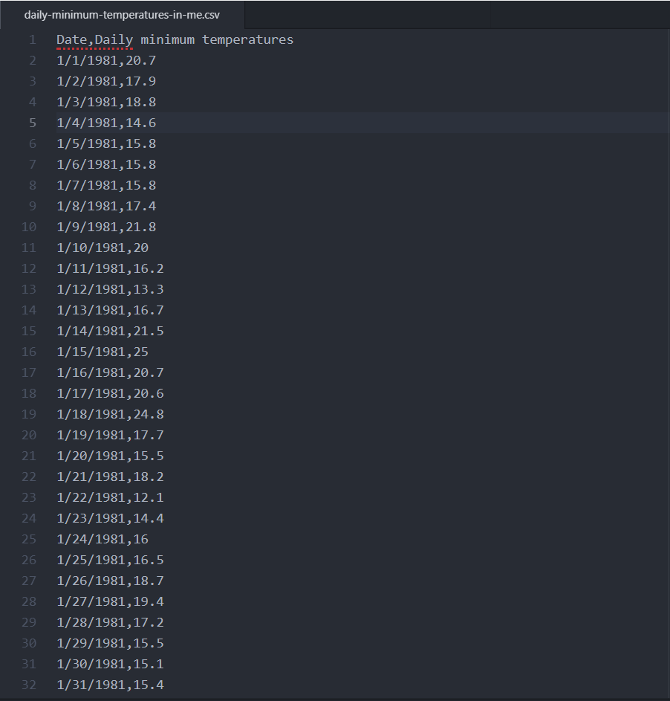

* The Date attribute is of the type Nominal and Daily minimum temperatures is in String format. 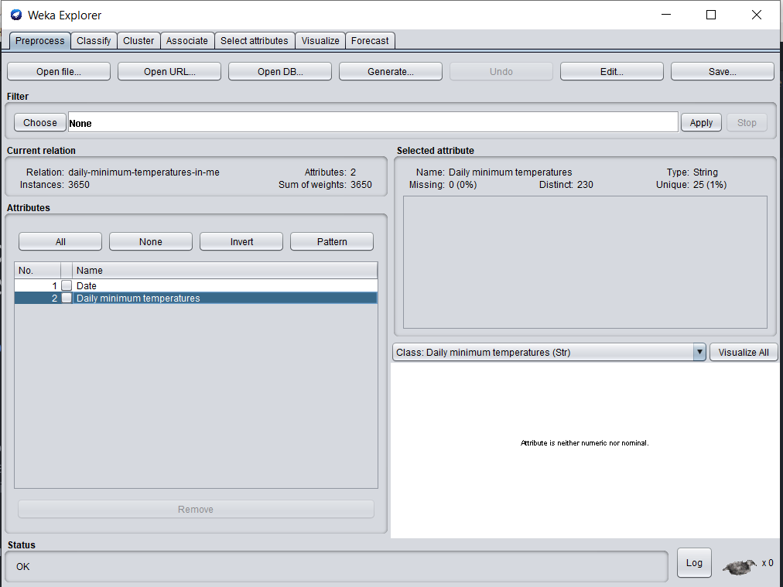
* **Preprocessing**

1. We initially need to convert the Date attribute to date type and Daily minimum temperatures to numeric type. We use StringToNominal filter to initially convert Daily minimum temperatures to the nominal type.

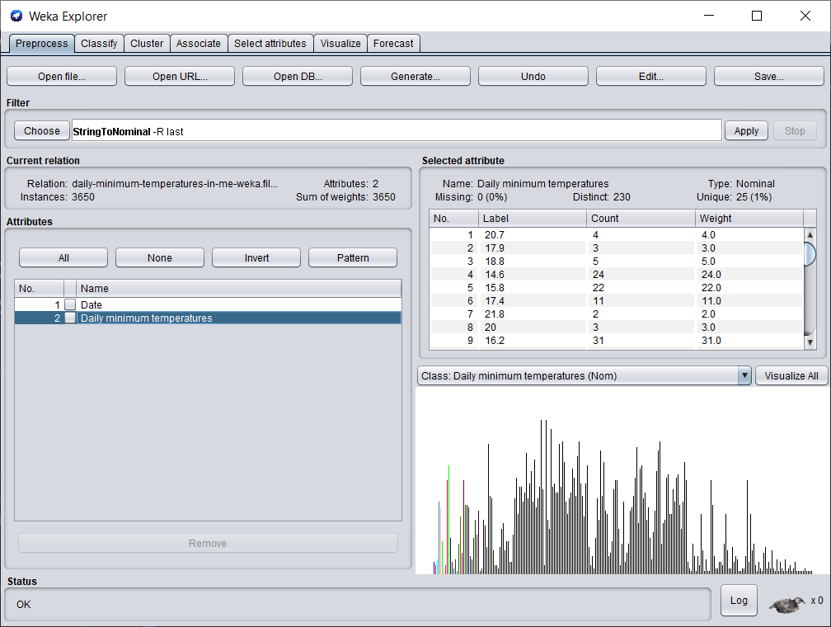

1. Next, we use a text editor to convert the attributes to their desired data type.

* Initial data type

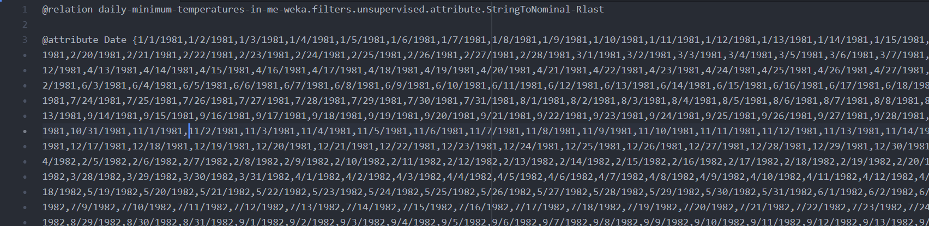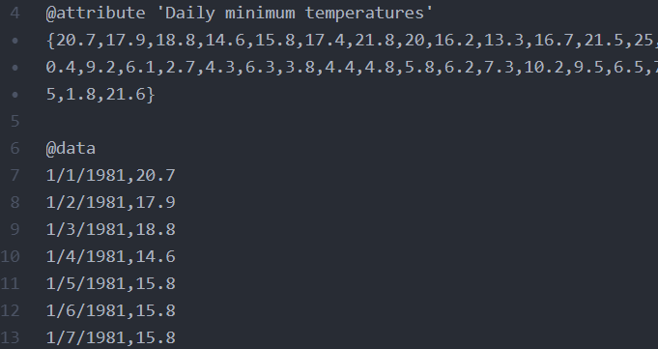

* Converted data type:

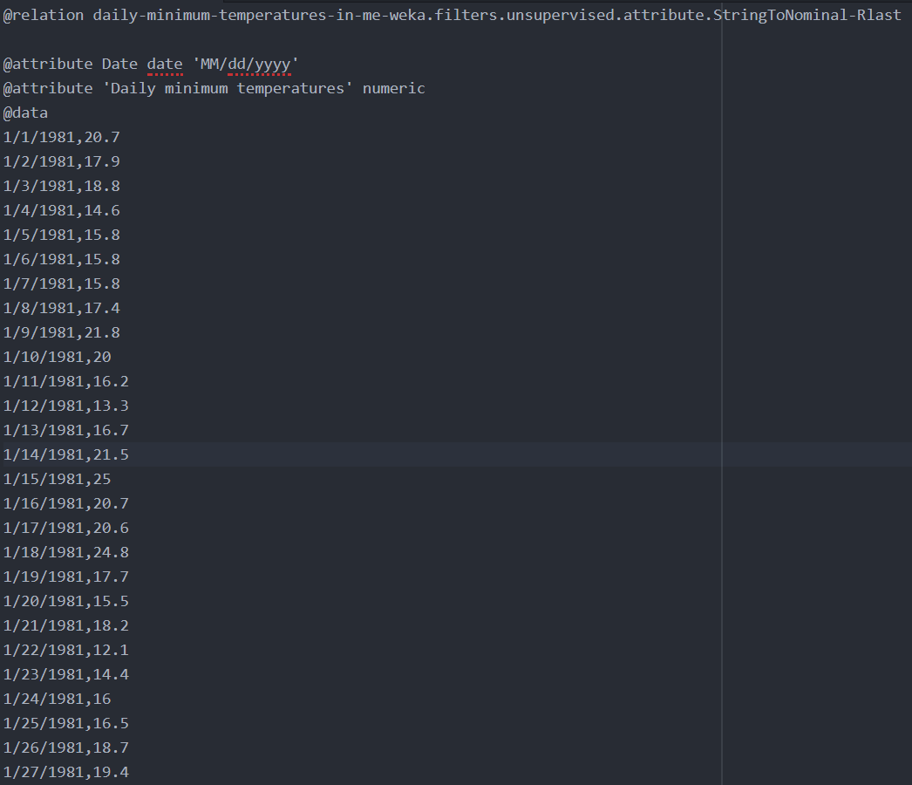

1. Write one or two paragraph analyzing the results of the forecasting. Support this analysis with screenshots of
   1. The regression equation
   2. Diagram of the historical values
   3. Diagram of the predictions

We use daily minimum temperatures as our target selection and date as the time stamp. Since we want to predict the daily minimum temperatures for the next two years, we set number of time units to forecast as 730. We use the default settings without making any changes.

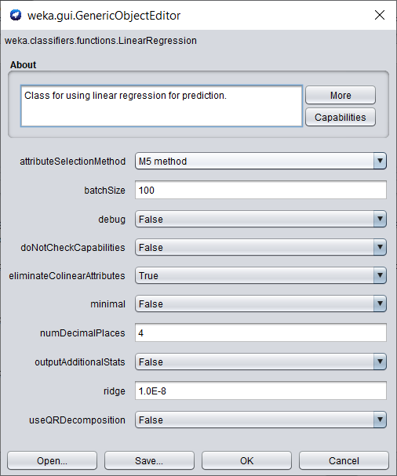

The default algorithm for prediction is Linear Regression which uses the Akaike criterion for model selection. The Akaike information criterion (AIC) is an estimator of the relative quality of statistical models for a given set of data. The evaluation metrics chosen are Mean absolute error (MAE) and Root mean squared error (RMSE).

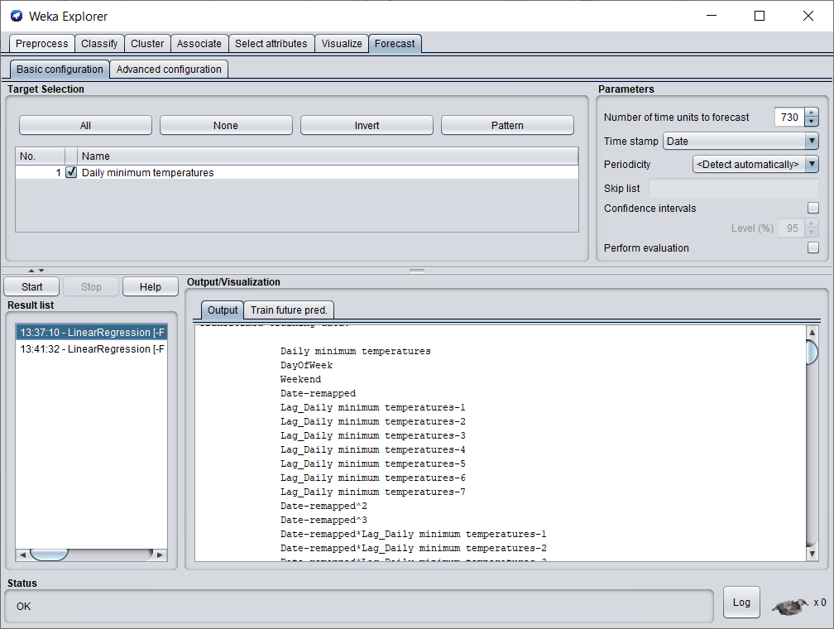

On choosing default values, DayOfWeek and Weekend are set as periodic attributes.

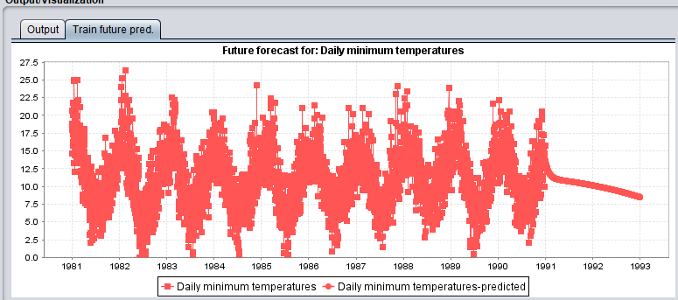

The forecast from the start of 1981 to the end of 1990 are historical values and from the start of 1991 to the end of 1992 are the predicted values. We can observe that the predictions seem to be incorrect as the predicted temperatures seem to be decreasing daily. The incorrect values could possibly be because the periodic attributes are set to DayOfWeek and Weekend. Hence, we change the periodic attributes and run the test again.

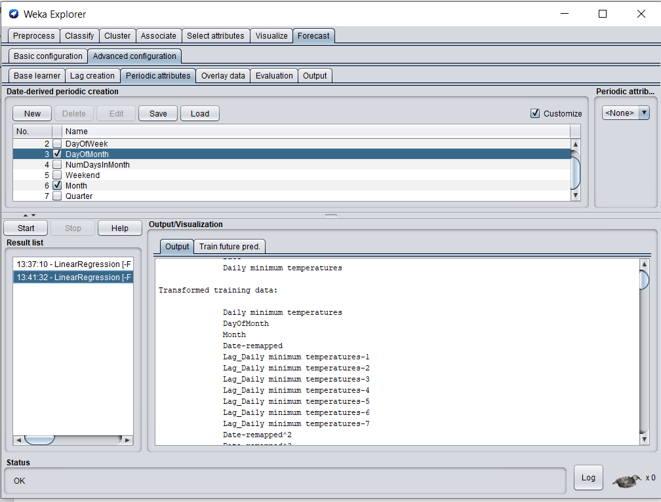

We set the Periodic attributes as DayOfMonth and Month because temperatures can change based on the month. We leave the other attributes as default and use the same algorithm i.e. Linear Regression.

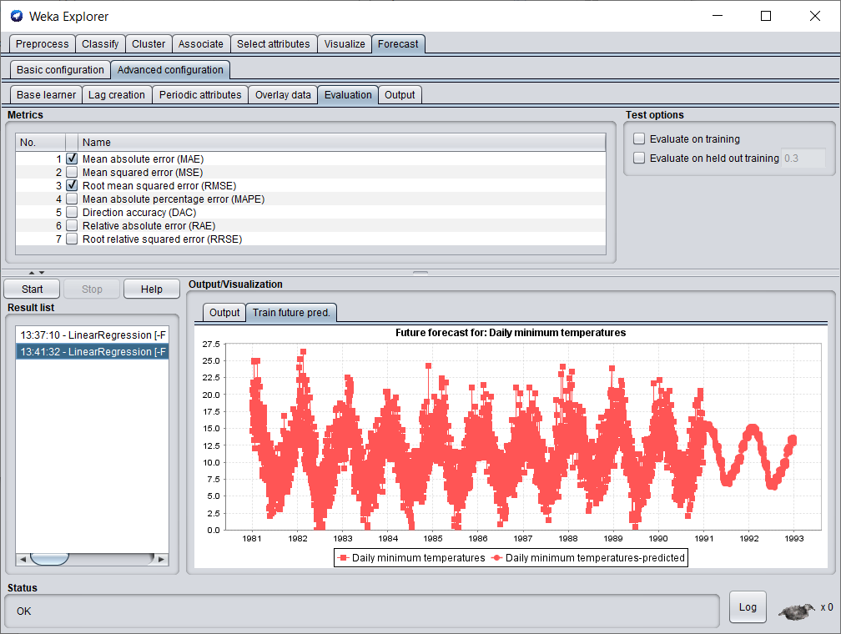

The forecast from the start of 1981 to the end of 1990 are historical values and from the start of 1991 to the end of 1992 are the predicted values. By changing the periodic attributes, we get a better prediction of the daily temperatures which seem to emulate the same pattern as the historical values.

Conclusion: Using historical data, we predicted the minimum temperature in Melbourne for the succeeding two years.

#### Research publication

1. **Title of the paper :**

Evaluation of partitioning clustering algorithms for processing social media data in tourism domain. (Available at <https://ieeexplore.ieee.org/document/8635080>)

1. **Publication and researchers :**

**Journal name :** IEEE, Recent Advances in Intelligent Computational Systems(RAICS), December 2018.

**Researchers :**

1. Shini Renjith, Department of Computer Applications , CUSAT , Kochi, India.
2. A. Sreekumar, Department of Computer Applications , CUSAT , Kochi, India.
3. M. Jathavedan , Department of Computer Applications , CUSAT , Kochi, India.

The main aim of the research was to examine different clustering techniques on social media data.

1. **Dataset :** This research article uses travel and tourism datasets. Three datasets are used
2. User interest information populated from destination reviews across South India published on holidayiq.com till October 2014. (Contains 249 user records with 6 interest attributes derived from more than 1500 reviews)
3. User’s average feedback/rating information on 10 categories of attractions in East Asia captured from tripadvisor.com. (Contains 980 user records with 10 feedback attributes inferred from numerous destination reviews)
4. User’s average rating information on 24 types of attractions across Europe captured from Google reviews.( Contains 5456 user records with 24 rating attributes).
5. **Techniques :**

Four different clustering algorithms are used , namely :

1. **K- means clustering** :

It is an unsupervised clustering algorithm where k stands for the number of clusters. All the entities of the data are grouped into k clusters depending upon the centroid. The centroid is the mean value of the entities.

1. **K-mediods clustering :**

It is similar to K-means , however it is less sensitive to noise and outliers in data. A mediod is a point in a cluster whose dissimalirity to other points is minimal. Datapoints are assigned to clusters depending on their closest mediods.

1. **Clustering for Large Applications (CLARA Algorithm):**

It is an extension of K-mediods formulated to handle large datasets. It uses the sampling approach. A small sample of the data is taken and K-mediods clustering technique is applied to it.

1. **Fuzzy C means :**

Fuzzy C-means Algorithm is considered as a soft clustering algorithm in which a data point can belong to all possible clusters to certain extent. Points are assigned to clusters depending upon their distance from the center points of the clusters.

1. **Major Findings**
2. The main objective of clustering is to find out optimal number of clusters in such a way that there is minimum inter cluster similarity within the cluster and maximum intra cluster similarity between two different clusters.
3. Two different mechanisms are used to find out how well the data is getting clustered.
4. **Silhouette Analysis :** predicts results by calculating average distance between clusters formed.
5. **Dunn Index :** Dunn Index is defined as the ratio of minimum separation to maximum intra cluster distance.
6. All four algorithms were performed on the 3 datasets :

Visualization of clusters generated:

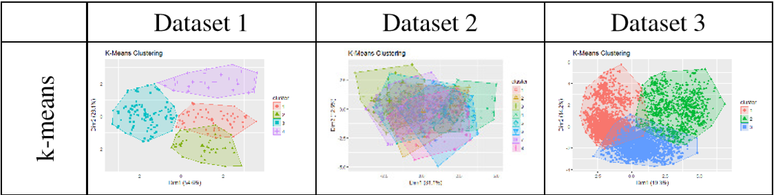

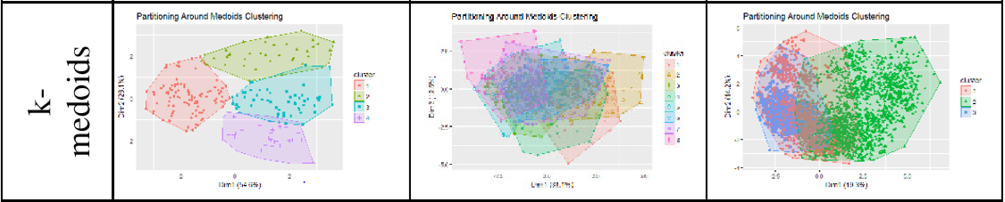

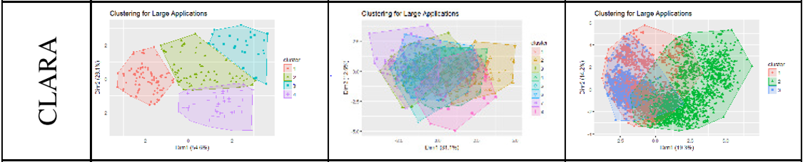

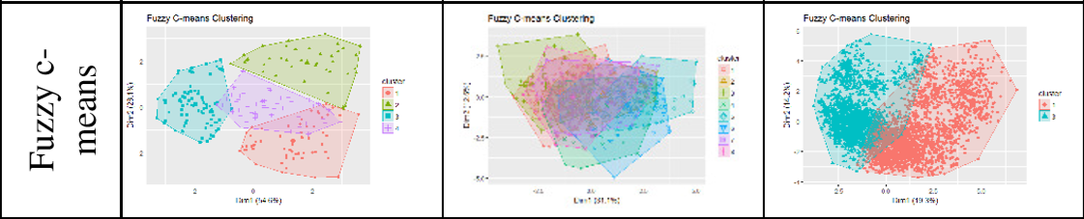

1. Different measures were used to calculate the performance of each algorithm . The measures used are as follows:
2. **Average silhouette width :** Average distance between two clusters
3. **Dunn index :** Minimum inter cluster distance divided by maximum cluster size (Higher the better)
4. **Dunn 2 index :** Min. avg. dissimilarity among two clusters / max. avg. within cluster dissimilarity.
5. **Entropy :** Entropy of distribution of clusters .
6. **Wb. Ratio :** Average distance within the cluster to average distance between the clusters.
7. A comparison table was generated and the following results were found out :

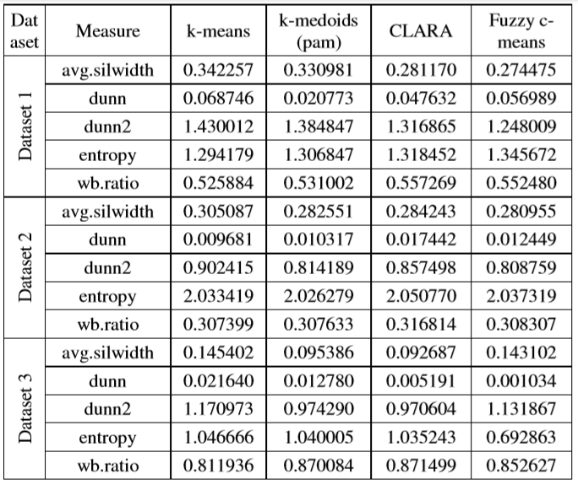

1. From the above table , all the performance measures were compared against each other. It was found out that, K-means clustering performs better than any other algorithm.
2. **Relevance to our work.**
3. As a part of the course, we learnt a module Data Mining Algorithms and techniques.
4. This involved learning more about classification and clustering techniques.
5. In clustering, K-means and K-mediods clustering was studied. This assignment itself K-means clustering was used on the same dataset as used in the research paper.
6. By reviewing of research paper, a better understanding of the K-means algorithm was developed. Also, other different techniques that are available for use were found out.
7. Methods to find performance statistics of the clustering algorithms was understood. Also, tools , packages and methods available for performing efficient clustering were understood.
8. This research paper has made the concepts of clustering more clearer and will help in the future while undertaking new data mining projects.